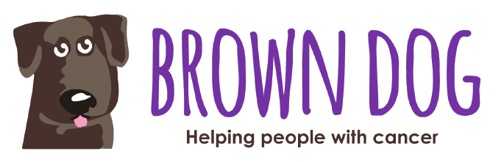

Dear

On the 20th June 2020 I will taking part in the Sca Fell Pike Challenge to raise money for the Brown Dog Charity who buy essential equipment to help people fight cancer.
In 2020 Brown Dog is trying to raise £46,000 to buy a Stem Cell Machine that will improve and extend the lives of people fighting Myeloma and Lymphoma cancer.
For the challenge I have to walk/climb Sca Fell Pike which is the highest mountain in England, which will take me 8 hours to complete.
This demanding challenge will be worth it if I can raise money for this extremely good cause – please can you help me?
I would be so grateful if you could make a donation using the
My Donate link below.
Thank you so much.
Name
Insert your my donate link here
www.cancerbrowndog.co.uk
Registered Charity 1111550
www.cancerbrowndog.co.uk
Registered Charity 1111550

