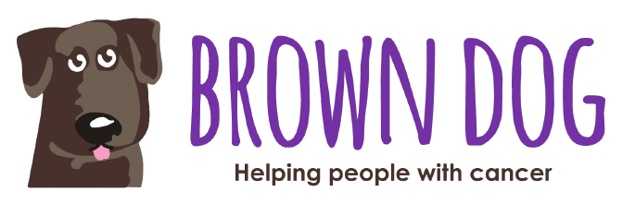

Dear [insert the name of your recipient(s)]

On the 18th of June 2022, I will be taking part in the Wordsworth Challenge to raise money for the Brown Dog Charity who buy essential equipment to help people fight cancer.
In 2022, Brown Dog is trying to raise £30,000 to buy an ultrathin transnasal endoscope for the Leicester Hospital Trust which will be used to improve the early detection of cancer.
For the challenge, I have to walk/climb 8 mountains in 14 hours, which involves getting up very early for an early start at 3am and climbing the first two mountains in the dark.
It is Brown Dog’s hardest challenge that offers some of the most breath-taking and beautiful scenery in the UK. The mountains include Sca Fell Pike which is the highest mountain in England.
This demanding challenge will be worth it if I can raise money for this extremely good cause – please can you help me?
I would be so grateful if you could make a donation using the Just Giving link below.
Thank you so much.
[Insert your name]
[Insert your Just Giving link here]
www.cancerbrowndog.co.uk
Registered Charity 1111550
www.cancerbrowndog.co.uk
Registered Charity 1111550

